Using spark-sql, Find:

1. What are the total number of gold medal winners every year

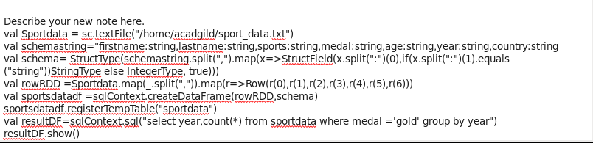

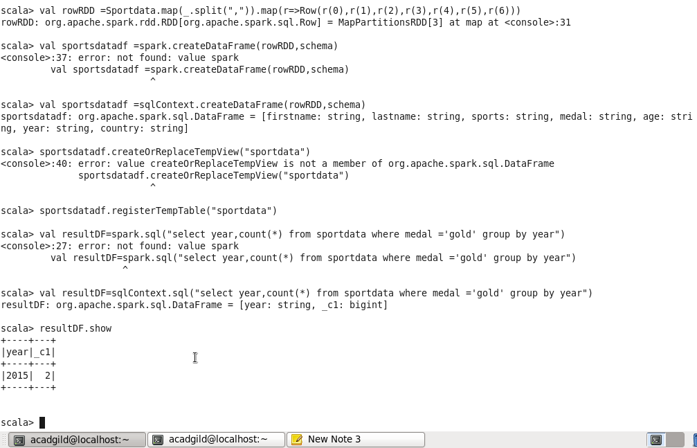

1. How many silver medals have been won by USA in each sport

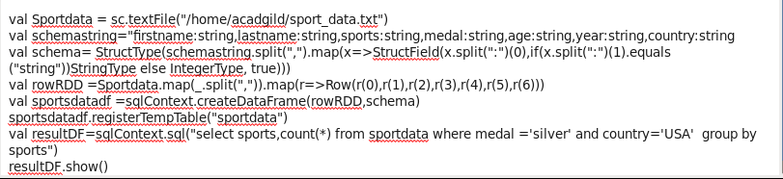

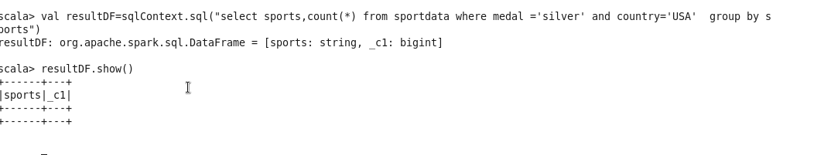

Dataset used for above problems

